How to run project

https://en.wikipedia.org/wiki/Connect_Four

1. Open Visual Studio 2017

Tools -> Options -> Debugging -> General -> [ ]Enable Just My Code

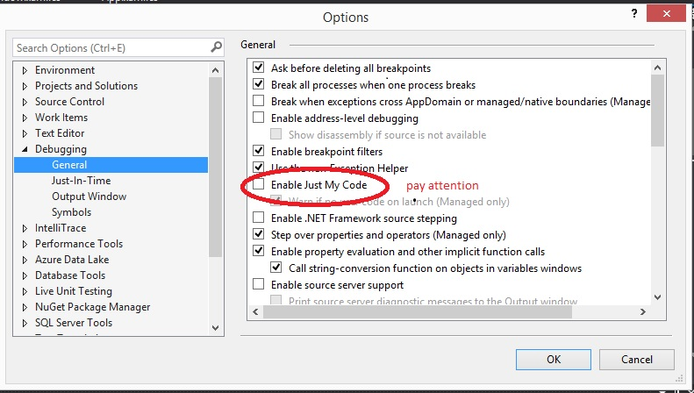

2. Open: \FourInLine\GameHost and run GameHost.sln --> Start

3. Open: \FourInLine\GameClient and run GameClient.sln -->Start

you must open two (or more) windows for two ( or more ) players

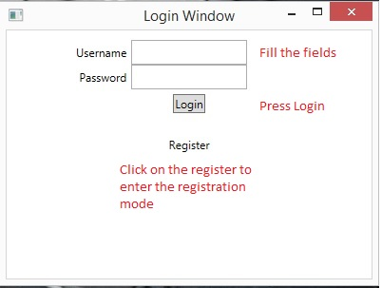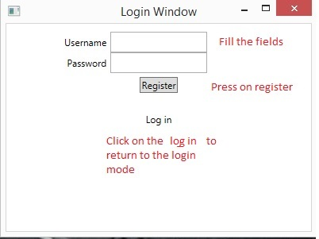

4. Log in or create new user

user : adam , pass : adam

user : bob , pass : bob

user : kim , pass : kim

user : uma , pass : uma

user : dan , pass : dan

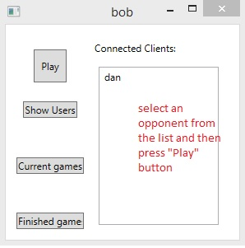5. Choose an opponent from the list and press "Play"

6. Your opponent must confirm that he wants to join the game

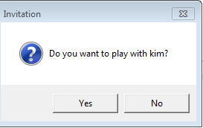

7. Enjoy the game

